H.T No
Regulations:
A15


Sreenidhi Institute of Science and Technology
(An Autonomous Institution)
Code No: 5FC04 Date: 26-Nov-2018 (AN)

B.Tech III-Year II-Semester External Examination, November - 2018 (Supplementary)
DESIGN AND ANALYSIS OF ALGORITHMS (ECM)

Time: 3 Hours Max.Marks:75

Note: a) No additional answer sheets will be provided.
b) All sub-parts of a question must be answered at one place only, otherwise it will not be valued.
c) Missing data can be assumed suitably.

Part - A Max.Marks:25

Answer all QUESTIONS.

1. | Derive the time complexity of recursive algorithm for sum of N real numbers using count method. | [3M]
2. | Write and explain control abstraction for divide and conquer. | [3M]
3. | Write and explain control abstraction for greedy method for the subset paradigm. | [3M]
4. | Compare and contrast greedy and dynamic programming approaches. | [3M]
5. | Draw the state space tree for 4-queens problem. | [3M]
6. | Define P and NP Class Problems. | [2M]
7. | Prove that 5n²-6n=ϴ(n²). | [2M]
8. | Draw a tree of calls of mergeSort(1,10). | [2M]
9. | Differentiate fixed and variable tuple size solutions in backtracking. | [2M]
10. | Explain divide and conquer procedure. | [2M]
Part – B Max.Marks:50
ANSWER ANY FIVE QUESTIONS. EACH QUESTION CARRIES 10 MARKS.

11. | a) | Explain the following asymptotic notations with an example. i) Big-O ii) Big-ϴ | [5M]
 | b) | In January, you buy a new car from a dealer who offers you the following maintenance contract: $50 each month other than March, June, September, and December, $100 every March, June, September, and $200 every December. Obtain an upper bound on the cost of this maintenance contract as a function of the number of months using all methods of amortized complexity. | [5M]
12. | a) | If k is a non-negative constant, then show that the solution to the given recurrence relation, for n a power of 2 is T(n)= 3knlog3 – 2kn.  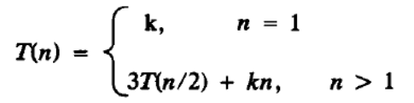 | [5M]
 | b) | Consider an array a[1:14]={-15, -6, 0,7,9,23,54,82,101,112,125,131,142,151}.  Using Binary Search determine the presence of keys 151, and -14. | [5M]
13. | a) | Compute a minimum cost spanning tree for the following graph using Prim’s Algorithm.  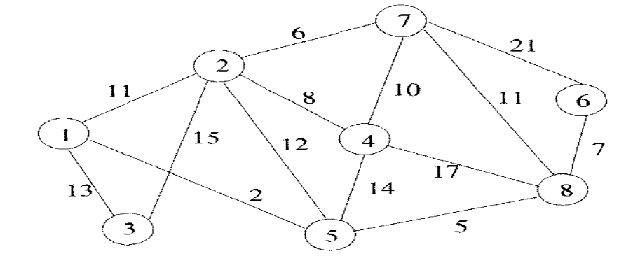 | [5M]
 | b) | Find an optimal solution for the following instance of job sequencing with deadlines: n=5, (p1:p5)=(20,15,10,5,1) and (d1:d5)=( 2,2,1,3,3). | [5M]
14. | a) | Apply dynamic programming for computing the minimum cost order of multiplying a string of four matrices whose dimensions are: 10X20, 20X50, 50X1, 1X100. | [5M]
 | b) | Design a three stage system with device types D1, D2, D3. The costs are Rs. 30, Rs. 15 and Rs. 20 respectively. The Costs of the system is to be not more than Rs. 105. The reliability of each device type is 0.9, 0.8 and 0.5 respectively. | [5M]
15. | a) | Define Hamiltonian cycle and write a Backtracking algorithm for finding all Hamiltonian cycles in a given graph | [5M]
 | b) | Draw the portion the State Space Tree generated by FIFOBB for the following Knapsack instance: n=4, (p1, p2, p3, p4) = (10, 10, 12, 18), (w1, w2, w3, w4) = (2, 4, 6, 9) and m=15. | [5M]
16. | a) | Explain Non Deterministic search and sorting algorithms. | [5M]
 | b) | State and prove Cook’s Theorem. | [5M]
17. | a) | What is amortized analysis? | [2M]
 | b) | Write an algorithm for quick-sort. | [5M]
 | c) | Distinguish feasible solution and optimal solution in Greedy method. | [3M]
18. |  | 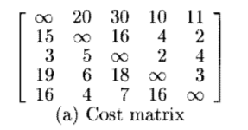  Consider the Traveling Salesperson instance defined by the cost matrix.
 | a) | Obtain the reduced cost matrix. | [2M]
 | b) | Using a State Space Tree formulation, obtain the portion of the State Space tree that will be generated by LCBB. Label each node by its Ĉ value; write out the reduced matrices corresponding to each of these nodes. | [8M]

-- 00 -- 00 –

